**ITRW 311**

**Chap 3**

1. What is a logical view of data?

* Relational database model enables logical representation of the data and its relationships
* Logical simplicity yields simple and effective database design methodologies
* Facilitated by the creation of data relationships based on a logical construct called a relation.

1. Characteristics of a relational Table:

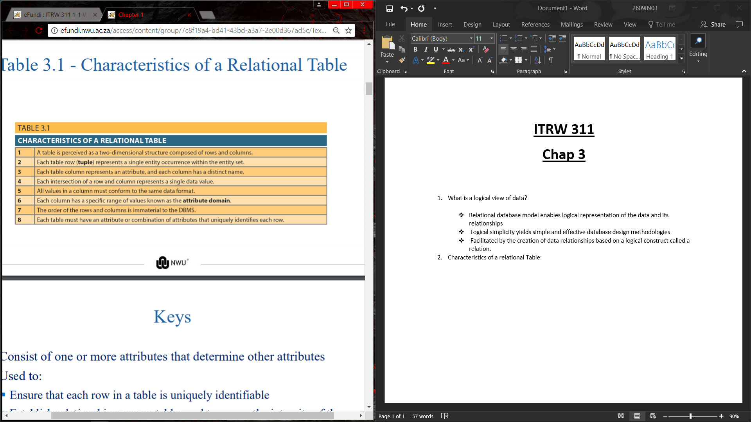

1. What are Keys?

Consist of one or more attributes that determine other attributes.

1. What are keys used for?

* Ensure that each row in a table is uniquely identifiable
* Establish relationships among tables and to ensure the integrity of the data

1. What is a primary key?

Attribute or combination of attributes that uniquely identifies any given row.

1. What is Determination?

* State in which knowing the value of one attribute makes it possible to determine the value of another.
* Basis for establishing the role of a key.
* Based on the relationships among the attributes.

1. Name and describe the different dependencies:

* **Functional dependence:** Value of one or more attributes determines the value of one or more other attributes.
* **Determinant:** Attribute whose value determines another
* **Dependent:** Attribute whose value is determined by the other attribute
* **Full functional dependence:** Entire collection of attributes in the determinant is necessary for the relationship

1. Name and describe the different types of keys:

* **Composite key:** Key that is composed of more than one attribute
* STU_NUM → STU_GPA
* (STU_LNAME, STU_FNAME, STU_INIT, STU_PHONE) → STU_HRS
* **Key attribute:** Attribute that is a part of a key
* **Entity integrity:** Condition in which each row in the table has its own unique identity
* All of the values in the primary key must be unique
* No key attribute in the primary key can contain a null.
* **Null:** Absence of any data value that could represent:
* An unknown attribute value
* A known, but missing, attribute value
* A inapplicable condition
* **Referential integrity:** Every reference to an entity instance by another entity instance is valid
* **Secondary key:** Key used strictly for data retrieval purposes

1. An Example of a Simple Relational Database:

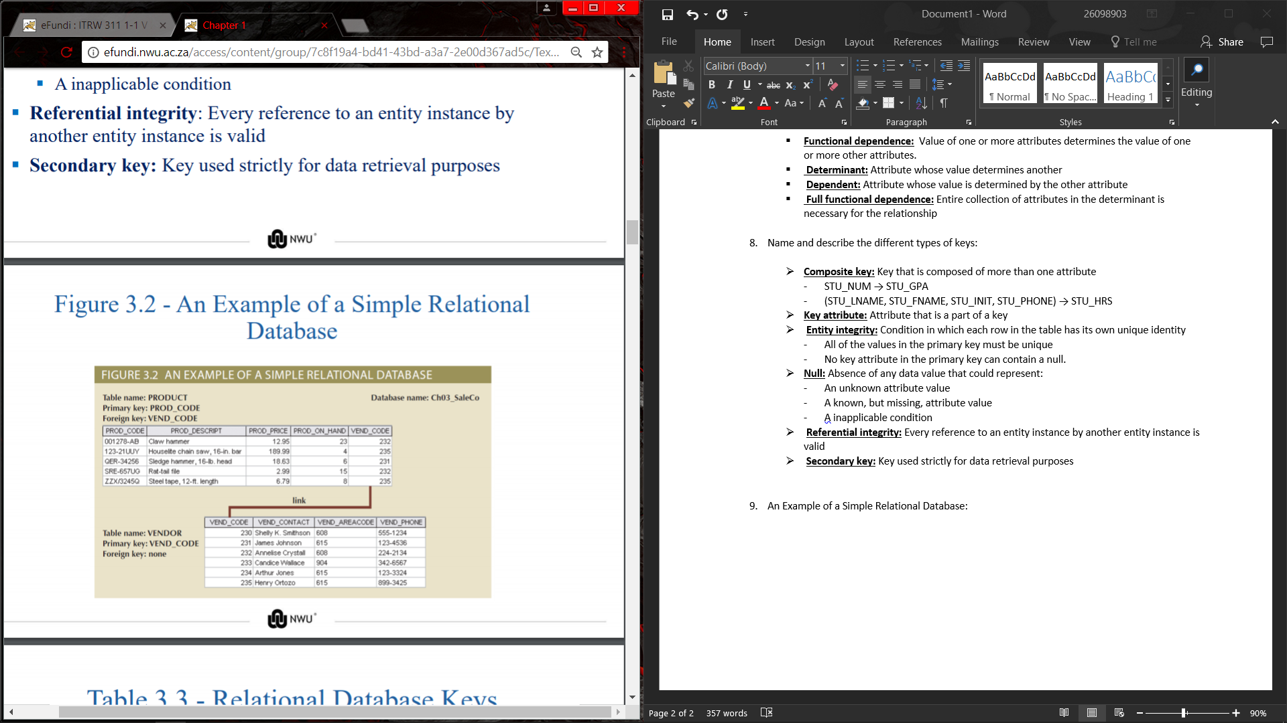

1. 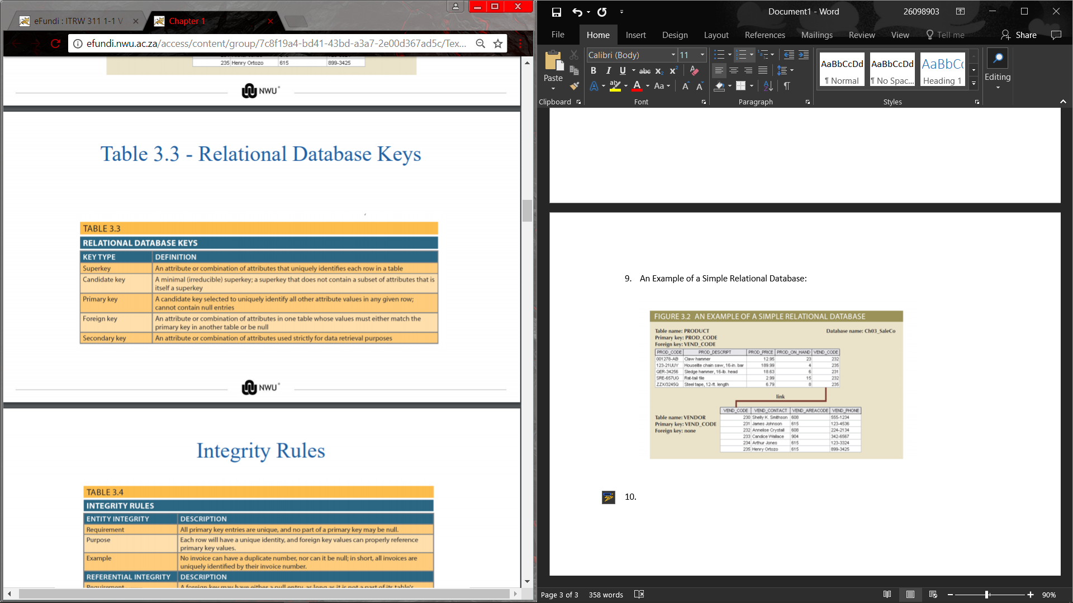Relational Database Keys:
2. Integrity Rules:

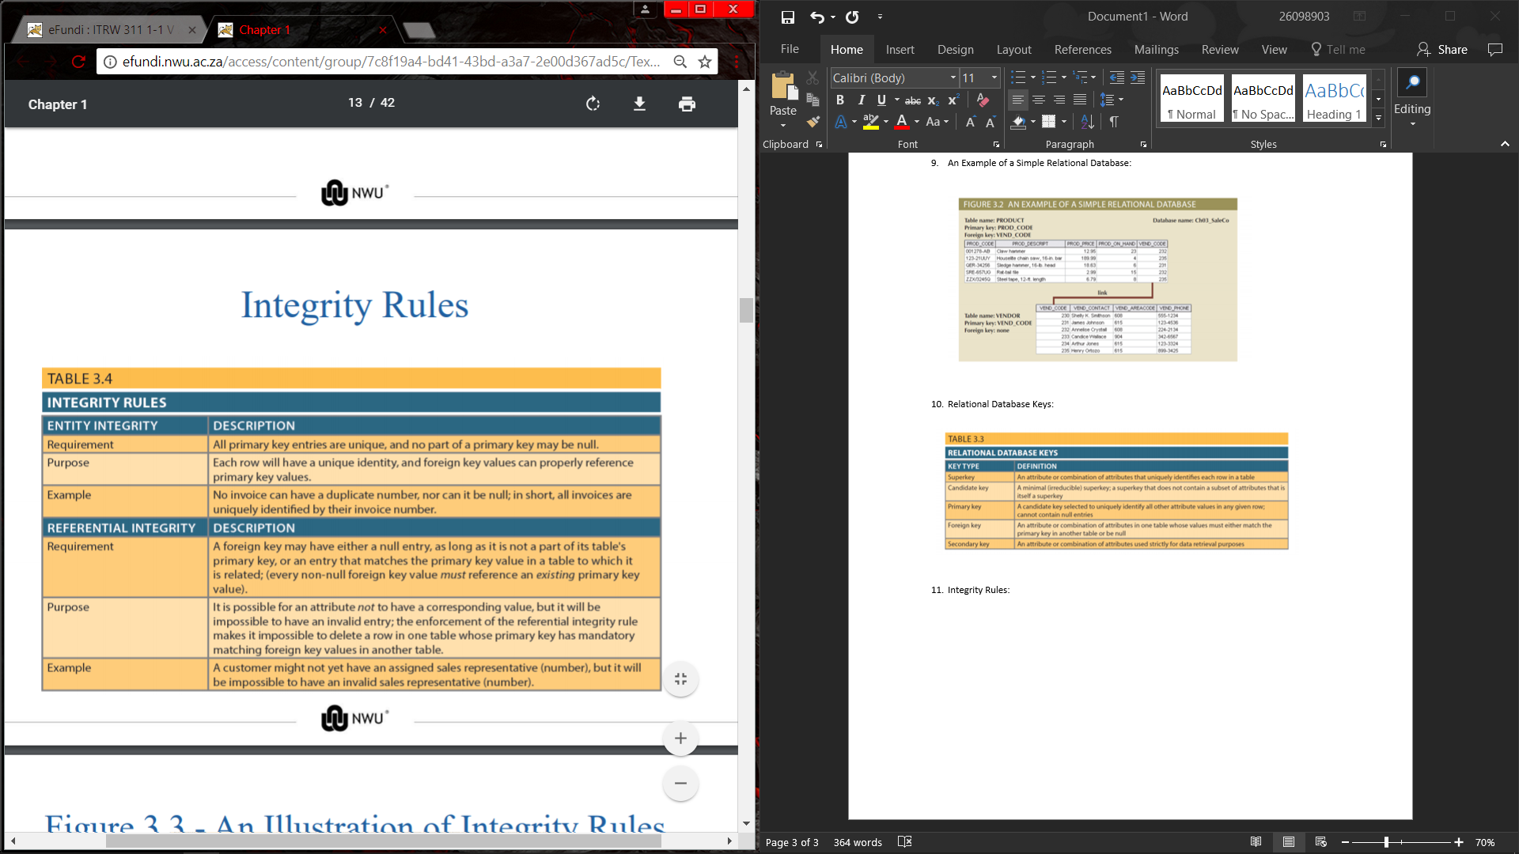

1. An Illustration of Integrity Rules:

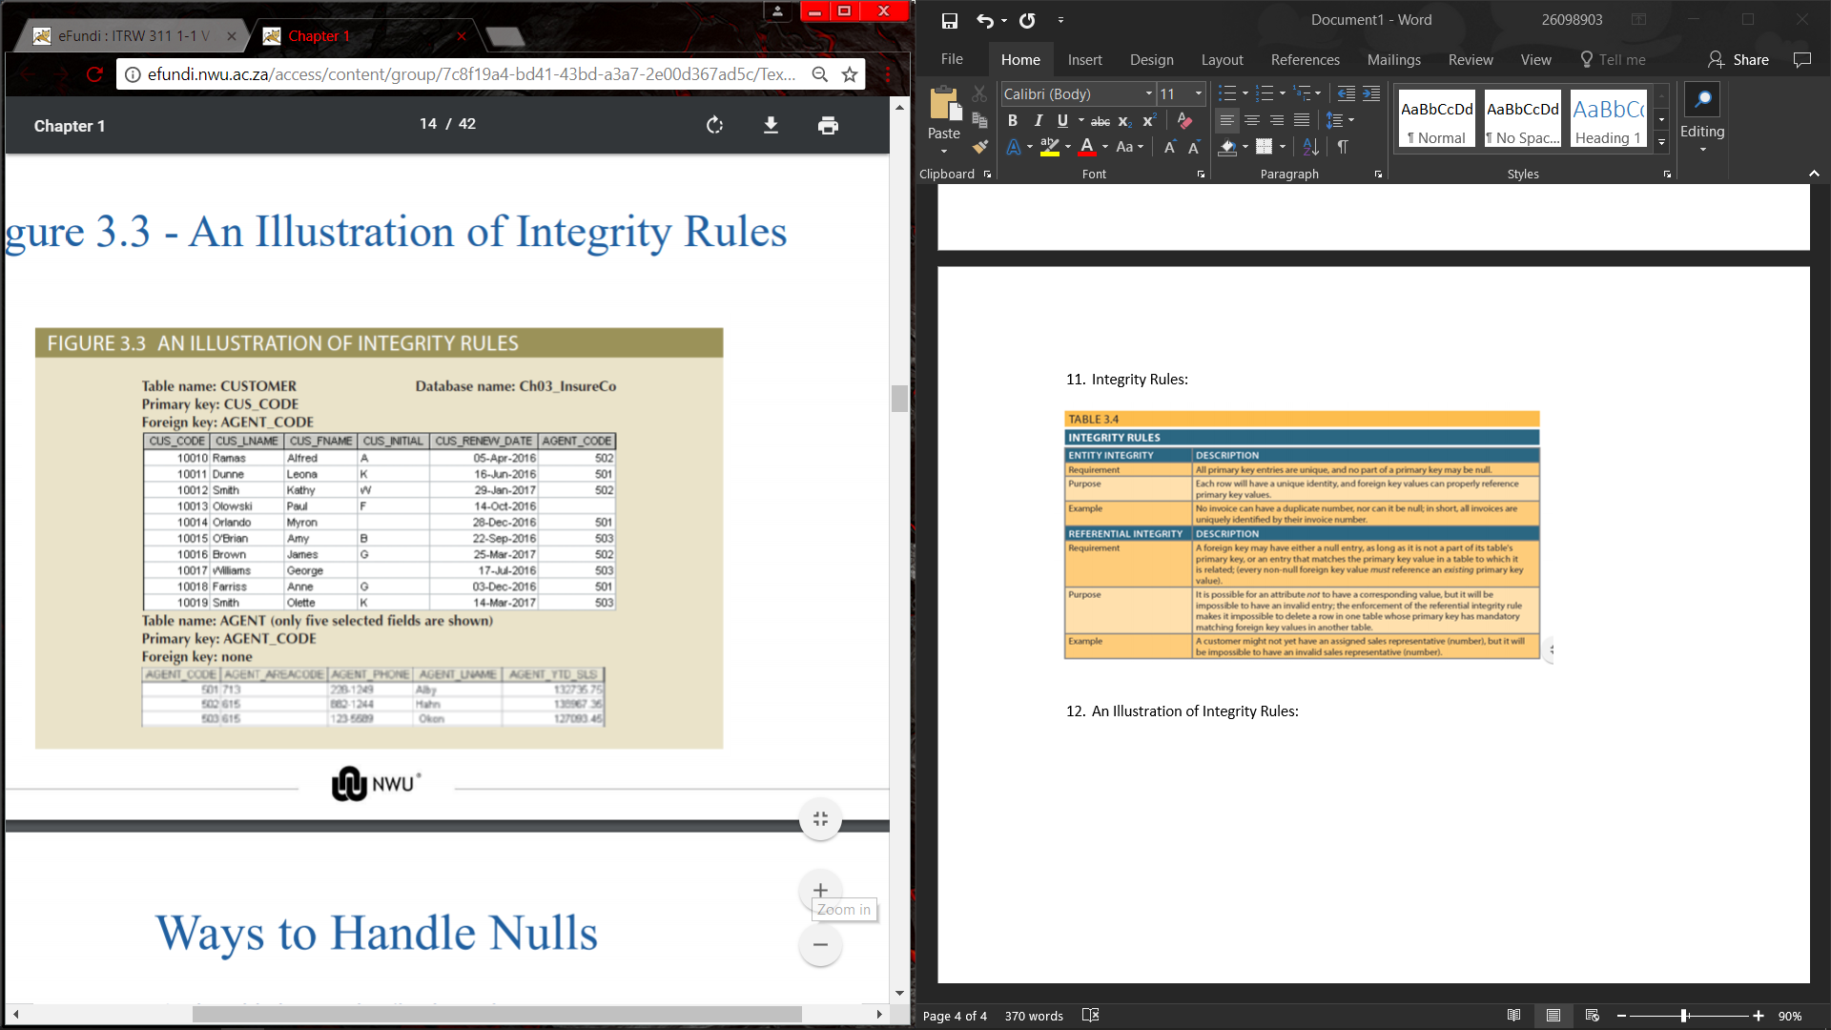

1. Name 3 different ways to handle Nulls:

* **Flags:** Special codes used to indicate the absence of some value.
* **NOT NULL constraint** - Placed on a column to ensure that every row in the table has a value for that column
* **UNIQUE constraint** - Restriction placed on a column to ensure that no duplicate values exist for that column

1. What is Relational Algebra?

* Theoretical way of manipulating table contents using relational operators.
* Relvar: Variable that holds a relation
* Heading contains the names of the attributes and the body contains the relation
* Example : When you create a table, the table structure holds the table data.
* The structure is properly called a Relvar and the data in the structure would be the relation.
* Relational operators have the property of closure; that is, the use of relational algebra on existing (relations) tables produces new relations

1. What are the Relational algebra’s operators?

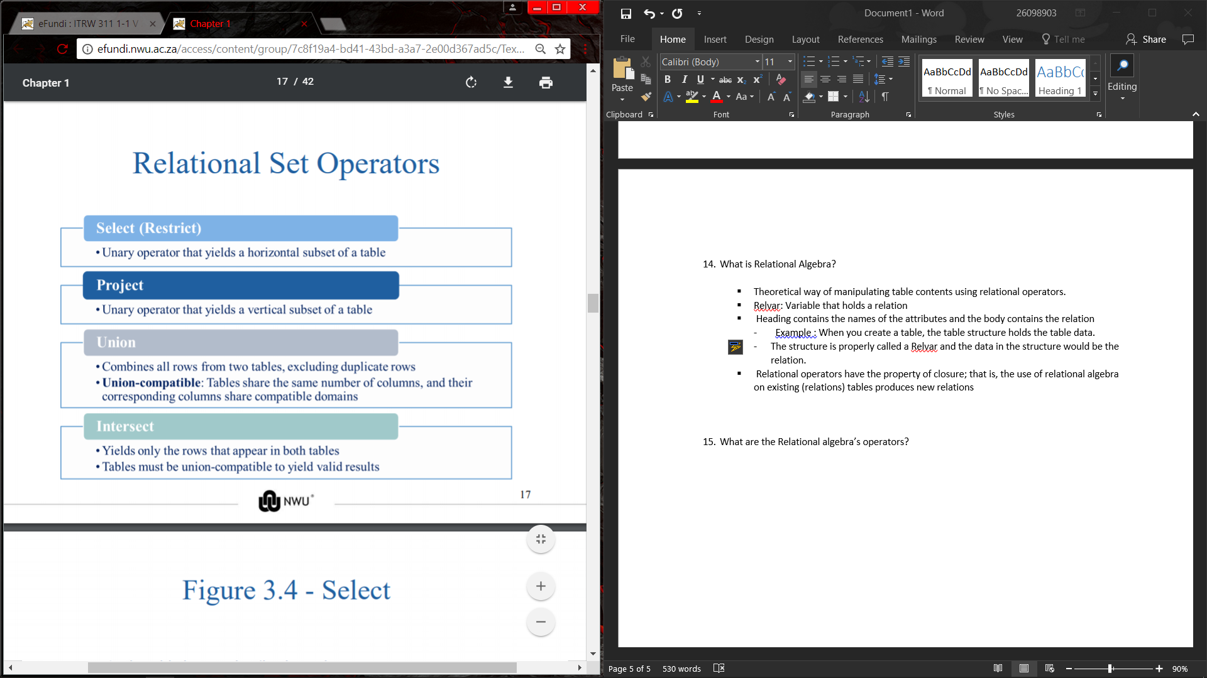

Gaan kyk in slides oor die voorbeelde van elke operatoe!!

1. What is the difference and product of Relational set operators?

* **Difference :**
* Yields all rows in one table that are not found in the other table
* Tables must be union-compatible to yield valid results
* **Product :**
* Yields all possible pairs of rows from two tables

Kyk ook na voorbeelde in slides.

1. What does the relational set operators join and divide do?

* **Join:**
* Allows information to be intelligently combined from two or more tables
* **Divide:**
* Uses one 2-column table as the dividend and one single-column table as the divisor
* Output is a single column that contains all values from the second column of the dividend that are associated with every row in the divisor.

1. Name and describe the types of joins:

* **Natural join:** Links tables by selecting only the rows with common values in their common attributes
* **Join columns:** Common columns
* **Equijoin:** Links tables on the basis of an equality condition that compares specified columns of each table
* **Theta join:** Extension of natural join, denoted by adding a theta subscript after the JOIN symbol
* **Inner join:** Only returns matched records from the tables that are being joined
* **Outer join:** Matched pairs are retained and unmatched values in the other table are left null
* **Left outer join:** Yields all of the rows in the first table, including those that do not have a matching value in the second table
* **Right outer join:** Yields all of the rows in the second table, including those that do not have matching values in the first table.

1. What is the data dictionary?

Description of all tables in the database created by the user and designer

1. What is the System catalog?

System data dictionary that describes all objects within the database

1. What is a Homonym and a Synonym?

* Homonym: Same name is used to label different attributes
* Synonym: Different names are used to describe the same attribute

1. What are the Relationships within the Relational Database?

* **1:M relationship** - Norm for relational databases
* **1:1 relationship** - One entity can be related to only one other entity and vice versa
* **Many-to-many (M:N)** relationship - Implemented by creating a new entity in 1:M relationships with the original entities
* **Composite entity (Bridge or associative entity):** Helps avoid problems inherent to M: N relationships, includes the primary keys of tables to be linked.

Kyk na voorbeelde van elek relationship in slides

1. How to control Data redundancy?

* Relational database facilitates control of data redundancies through use of foreign keys
* The proper use of foreign keys is crucial to controlling data redundancy, although they do not totally eliminate the problem because the foreign key values can be repeated many times.
* However, the proper use of foreign keys minimizes data redundancies and the chances that destructive data anomalies will develop.

1. What is an index and what are the different types of indexes?

* Orderly arrangement to logically access rows in a table
* **Index key:** Index’s reference point that leads to data location identified by the key
* **Unique index:** Index key can have only one pointer value associated with it
* A table can have many indexes but each index is associated with only one table.

1. Dr. Codd’s 12 Relational Database Rules:

